
CS5226 Project
Database Performance
Dashboard Report
(Apr 2013)

Team 10

A0079949 - Jiang Haomin
A0079953 - Lee Zhongde
A0080037 - Zhou Zifeng
A0079995 - Guo Yu

Contents

1. System Overall Architecture 3
2. Database Design 4
3. Statics Computation 5
4. Screenshot of Applications 8
5. Lesson Learnt 12
6. Project Admin 14

System Overall Architecture

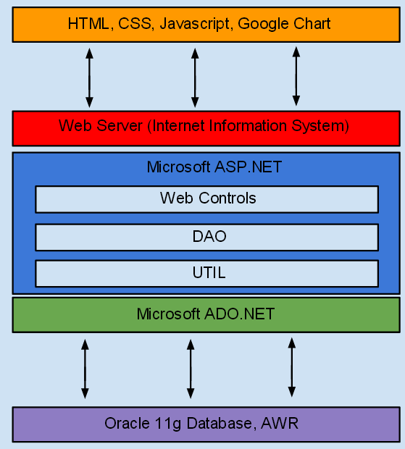

Database Design

Data tables used by the Dashboard system

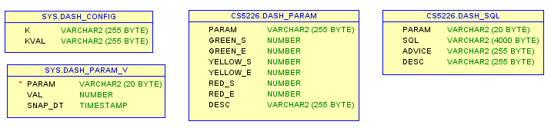

# | Table Name | Description
1 | DASH_CONFIG | This table is used to store the configuration data of the system. Some configuration data include X & Y Interval’s Minutes
2 | DASH_PARAM | This table stores the parameters color indicator start and end value. The indicator value will be defined by the user
3 | DASH_SQL | This table stores the SQL scripts that will be used for giving advice to DBA when the indicator of the parameters been monitored turn red
4 | DASH_PARA_V | This table stores the snapshot data of the parameters been monitored

Data tables that contain fabricated data used to simulate data loading
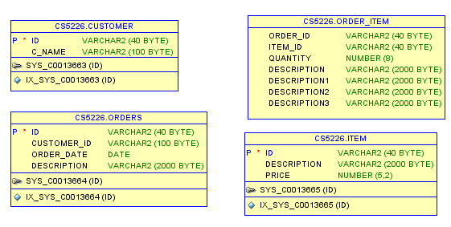

Statics Computation
# | Description | SQL Script
1 | Shared Pool Usage | select round((info.bytes - stat.bytes) / info.bytes * 100, 2)  from v$sgainfo info, v$sgastat stat  where info.name = 'Shared Pool Size' and stat.pool = 'shared pool' and lower(stat.name) = 'free memory';  -- Lower percentage is good.
2 | Cache Buffer Hit Ratio | SELECT ROUND((1-(phy.VALUE / (cur.VALUE + con.VALUE)))*100,2) as Cache_Hit_Ratio  FROM v$sysstat cur, v$sysstat con, v$sysstat phy  WHERE cur.name = 'db block gets'  AND con.name = 'consistent gets'  AND phy.name = 'physical reads';  -- Higher ratio is good.
3 | Redo Log Buffer Ratio | select a.value/b.value * 100 redo_buffer_entries_ratio  from v$sysstat a, v$sysstat b  where a.name = 'redo buffer allocation retries'  and b.name = 'redo entries';
4 | Sorting Area Usage | SELECT mem.value*100/(disk.value + mem.value)  FROM v$sysstat disk, v$sysstat mem  WHERE mem.name = 'sorts (memory)'  AND disk.name = 'sorts (disk)';
5 | Generate AWR report in HTML format | select output from table(dbms_workload_repository.awr_report_html(@dbid, @instancNum, @snap_start_id, @snap_end_id, 0));
6 | Update AWR Snapshot Interval & Retention Period (Minutes) | dbms_workload_repository.modify_snapshot_settings(  retention => 7200,  interval => 30);
7 | Get Current AWR Snapshot Interval & Retention Period | SELECT extract(day from snap_interval) *24*60+extract(hour from snap_interval) *60+extract(minute from snap_interval) snapshot_Interval,  extract(day from retention) *24*60+extract(hour from retention) *60+extract(minute from retention) retention_Interval  FROM dba_hist_wr_control;
8 | Share Pool Advisor | SELECT  shared_pool_size_for_estimate as "Share Pool Size (MB)",  shared_pool_size_factor as "SP Size Factor",  estd_lc_size as "Est LC Size (MB)",  estd_lc_memory_objects as "Est LC Memory Obj",  estd_lc_time_saved as "Est LC Time Saved (s)",  estd_lc_time_saved_factor as "Est LC Time Saved Factor",  estd_lc_load_time as "Est LC Load Time (s)",  estd_lc_load_time_factor as "Est LC Load Time Factor",  round(estd_lc_memory_object_hits/1024) as "Est LC Memory Obj Hits (K)"  FROM  v$shared_pool_advice;
9 | Cache Buffer Advisor | select  size_for_estimate as "Size for Est (MB)",  size_factor as "Size Factor",  round(buffers_for_estimate/1024) as "Buffers (K)",  estd_physical_read_factor as "Est Phys Read Factor",  round(estd_physical_reads/1024) as "Est Phys Reads (K)",  estd_physical_read_time as "Est Phys Read Time",  estd_pct_of_db_time_for_reads as "Est %DBtime for Rds"  from v$db_cache_advice  where name = 'DEFAULT'  and advice_status = 'ON'  and block_size = (SELECT value FROM V$PARAMETER WHERE name = 'db_block_size');
10 | Log Buffer Suggest Value | select optimal_logfile_size from V$INSTANCE_RECOVERY;
11 | PGA | select  round(pga_target_for_estimate/1024/1024) as "PGA Target Est (MB)",  pga_target_factor as "Size Factor",  round(bytes_processed/1024/1024) as "W/A Processed (MB)",  round(estd_extra_bytes_rw/1024/1024) as "Estd Extra W/A to Disk (MB)",  estd_pga_cache_hit_percentage as "Estd PGA Cache Hit %",  estd_overalloc_count as "Estd PGA Overalloc Count",  estd_time as "Estd Time"  from v$pga_target_advice;

4. Screenshot of Applications
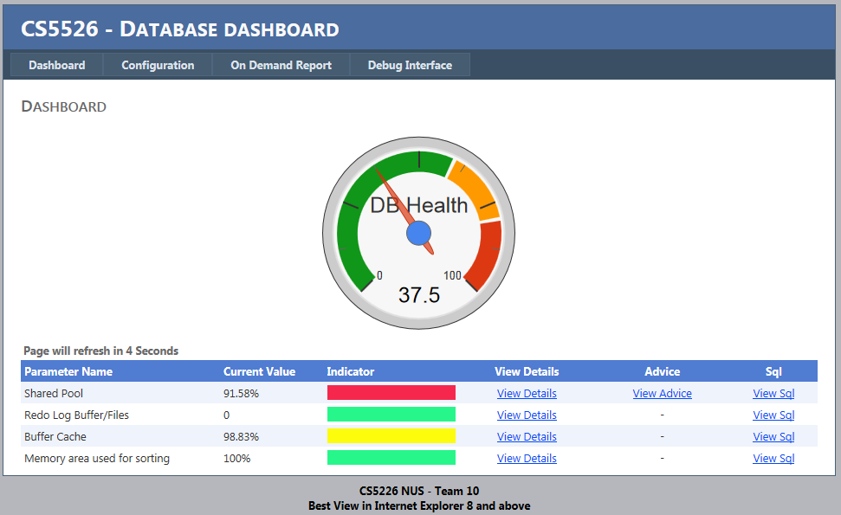

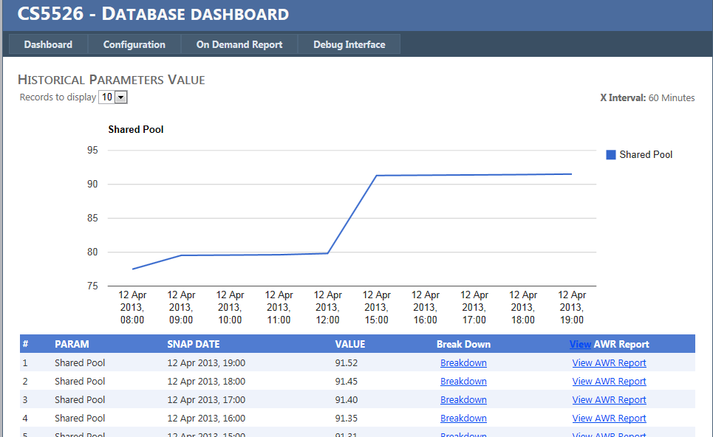
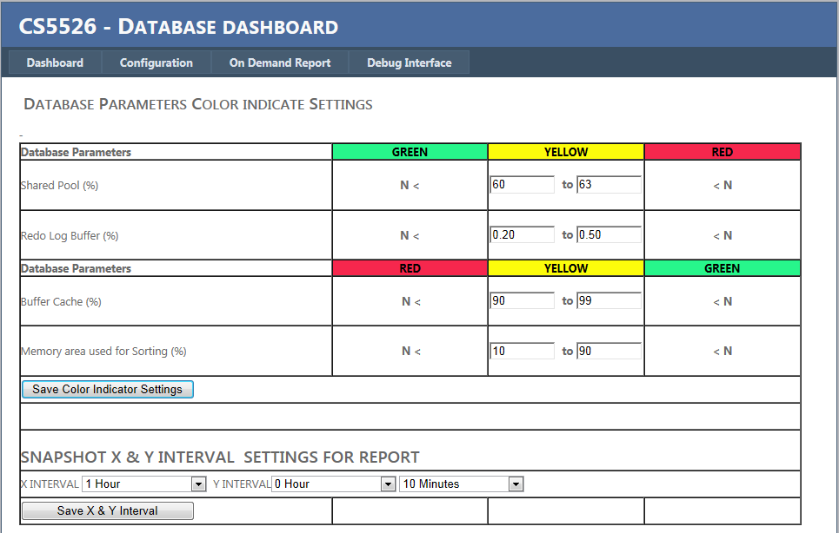

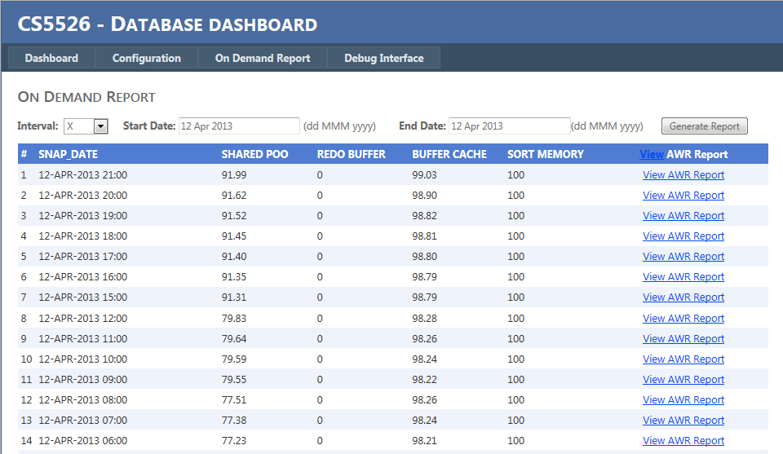

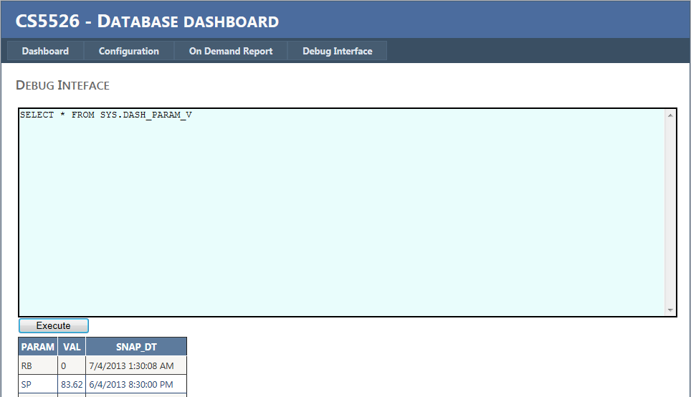
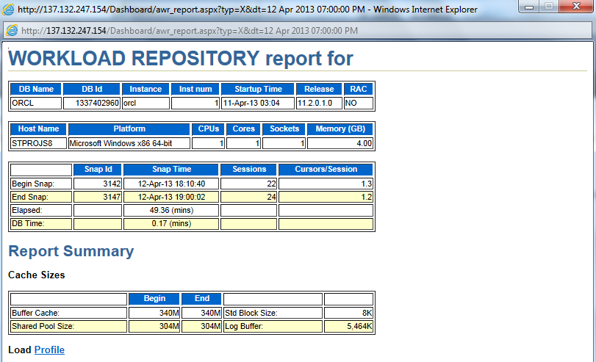

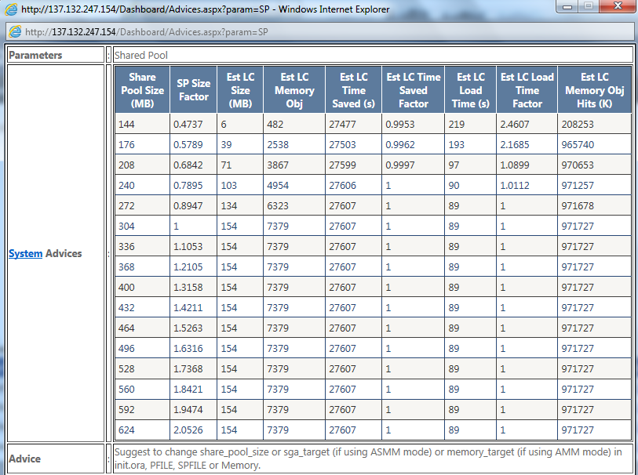

5. Lesson Learnt
1) According to do this project, we’re more familiar with Oracle memory structure. An instance associated with two basic memory structures:

  - System Global Area (SGA): It’s the group of shared memory structure that contains data and control information for one Oracle DB instance. The SGA is shared by all server and background processes.

  - Program Global Area (PGA): Memory regions that contain data and control information for a server or background process. A PGA is non-shared memory created by Oracle DB when a server or background process is started. Access to PGA is exclusive to the server process.

The SGA includes many area structures as the following:

  - Shared Pool: Caches various constructs that can be shared among users. It includes Library Cache (command text, parsed code and execution plan), Data Dictionary Cache (definitions for tables, columns and privileges from data dictionary tables), Result Cache (result from SQL query and PL/SQL functions) and User Global Area (session info for oracle shared server).

  - Buffer Cache: Caches blocks of data retrieved from the database. Oracle bypasses the buffer cache for particular operations, such as sorting and parallel reads.

  - Redo Log Buffer: Cache redo information (used for instance recovery) until it can be written to the physical redo log files stored on the disk. It’s a circular buffer in SGA. Holds information about changes made to the database. Contains redo entries that have the information to redo changes made by operations such as DML and DDL.

  - Large Pool: Optional area that provides large memory allocations for certain large processes, such as Oracle backup and recovery operations.

  - Java Pool: Used for all session-specific Java code and data in the JVM.

  - Stream Pool: Used by Oracle Streams to store information required by capture and apply.

The PGA contains the following four areas:

  - Work Area: For complex queries, a big portion of PGA is dedicated to work areas allocated by memory-intensive operators, such as Sort-based operators, Hash-join, Bitmap merge, Bitmap create or Write buffers used by bulk load operations. A sort operator uses the sort area in a work area to perform the in-memory sort of a set of rows.

  - Private SQL Area: It contains data such as bind information and run-time memory structures.

  - Cursor and SQL Area: Oracle Pro*C program or Oracle Call Interface(OCI) program can explicitly open cursors or handles to specific private SQL areas, and use them as a named resource throughout the execution of the program.
  - Session Memory: It holds a session’s variables (logon info) and other information related to the session.

2) Advanced Workload Repository (AWR)

AWR is to collect database statistics (by default every hour) and this data is maintained for a week and then purged. Run reports against these statistics to performance tune the database. In order to properly collect database statistics, the parameter STATISTICS_LEVEL should be set to TYPICAL (default value) or ALL.

6. Project Admin
# | Task | Member
1 | - Creation of SQL scripts on parameters value, advice, computation script, analyze of parameters needed to be tracked, snapshot script, AWR report extraction etc  - Creation of data loading script to simulate large data creation and selection  - Create scheduled job to run the data loading simulation | Hao Min, Guo Yu
2 | - Create frontend web application, connection to oracle database, defined database general health computation  - Created batch job to perform database snapshot that will be used in on demand /awr report  - System Testing to ensure system stability | Rollei, Zi Feng
3 | Project Documentation | All member

